Pinner memorial park was adopted in a 2002 Unitary Development Plan meeting
The enhanced local list description was approved at Cabinet on 21st February 2019
Pinner Memorial Park Local List Description:
Identification and summary of interest: Pinner Memorial Park comprises the landscaped grounds around West House, former home of Nelson’s grandson and later location of two Books of Remembrance, as a public memorial to the people of Pinner who gave their lives defending freedom against intolerance, racism and oppression and was opened in 1950. West House (locally listed) remains as a facility for the community with a café and the Heath Robinson Museum has been built alongside. [NB The Museum is called the Heath Robinson Museum.] Some of the associated designed landscaping to West House also remains from the 19th century. The park and West House form a significant part of Pinner’s heritage as a single entity which has evolved from the 14th century to the present day. Grounds and house purchased through public subscription as a living memorial, for the public to enjoy, after the war.
History/intactness/representative of a type: In 1390 West House and grounds were a yeoman holding, situated at the heart of the then hamlet of West End, belonging to John Aldridge. By 1800 the holding had evolved into a gentleman’s country house and its land was transformed into the ornamental gardens, with lake and artificial island near the house, and wilder park beyond, which were so essential to the aspiring 19th century gentry. The ornamental lake (fountain added in 1980), walled garden and several trees including Corsican Pine to north and south and one or two earlier Oaks all survive from the earlier grounds, in combination with the later attributes when donated for use as a war memorial in the late 1940s and opened in 1950 after a public campaign. The trees in the park are both native and exotic, and include larch, weeping willow, blue cedar, magnolia, copper beach and swamp cypress. The ornamental lake, in existence by 1864, was in its present form by 1894. There is a small dog cemetery near the entrance at the north-west which dates from the 19th century.

Public park features introduced when the transition to a memorial was made that remain today include two banks in the centre of the park planted up with shrubberies; rockery west of lake; floral displays in walled garden which is now designated as Peace Garden with heathers, rose beds and clematis. The Peace Garden is located in the north west corner of Pinner Memorial Park enclosed by a low brick wall with steel railings on the two road boundaries, a brick wall on the east and a post and panel fence on the south, the Peace garden is also identified as the walled garden. The brickwork of the wall is similar to the buff coloured brick used at West House and West House Lodge and the line of the wall is shown on the 1894 Ordnance Survey map. The large pear tree adjacent to the wall is one of the trees remaining from the early walled garden.

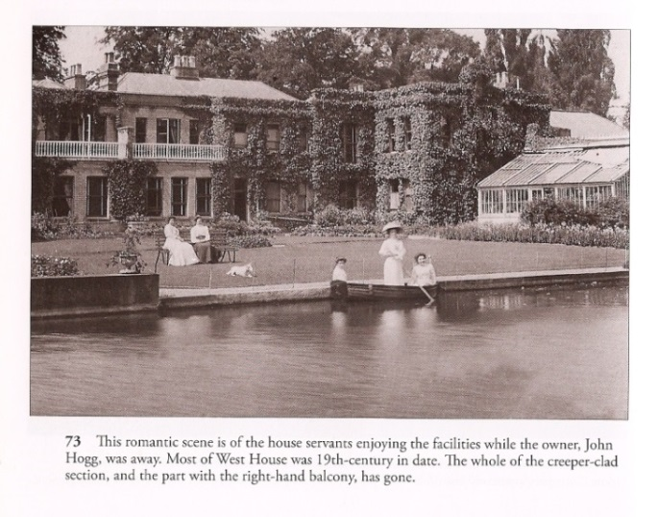
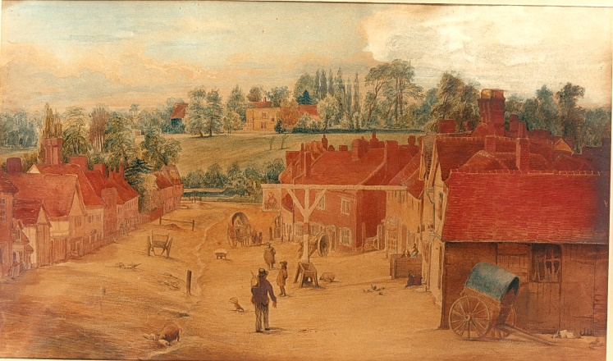
Pictures: Views towards West House in the 19th century
In 1995 the peace garden had revised planting and layout for 1995 with input from the council and locals, the 50 year remembrance of the end of World War II. The dove motif was designed by pupils from Nower Hill High School as an appropriate symbol of peace. Within the peace garden, four curved and hedged rose garden segments in lawn surround a large weeping ash. There are eight dark green painted steel obelisks on the rose garden inner corners. Roses and clematis climb the obelisks. Fastigiate yews centred at the back of each rose garden provide further vertical emphasis. The perimeter path is Breedon gravel leading to the west entrances near the playground and to the pedestrian entrance/exit at West End Lane. The herbaceous border of roses and other flowering perennials against a broadleaf evergreen backdrop of Griselinia littoralis and planted in 2012. It is punctuated with additional planting of flowering almond and juniper sky rocket trees. The Holm oak, Quercus ilex is the tallest tree on the north boundary and an arbutus provides additional interest. The tall shrubs and trees on the road boundaries screen the Peace Garden and reduce noise. Similarly, in 1995 Chapel Lane was improved with railings, paviours and plaque erected commemorating the ‘donation of the park by the people of Pinner in memory of those who gave their lives in the war’.

The aviary was constructed in 1958 replaced with a larger one in the 1970s/80s. The aviary is built against the boundary wall with West End Lodge and occupies a small part of the large footprint of the former greenhouse, a feature in postcards of West House from the 19th century. The brick wall adjacent to the aviary supports a well-trained wisteria which flowers abundantly in summer, maintained by the Pinner Association

Association with other heritage assets: There is a strong association with the locally listed West House since the park forms the former grounds to this. The park also forms a good adjunct and setting to the Pinner High Street and Waxwell Lane Conservation Area. As the Pinner Conservation Areas (CAs) Supplementary Planning Document states: ‘The physical and aesthetic attributes of open space should not be underestimated. …the leisure, environmental and aesthetic benefits of Pinner Memorial Park are significant to Pinner High Street and Waxwell Lane CAs’.

Association with significant persons or historic events: Nelson Ward, the grandson of Lord Horatio Nelson (hero of Trafalgar) and Emma Hamilton, lived at West House within the park from 1873 to 1883. In the 1860s Lord Nelson’s daughter Horatia lived at West End Lodge opposite West House, now a school, and her son Nelson ward lived at West House.

During World War II the grounds to West House were used for Civil Defence purposes with a trench air raid shelter and a British Restaurant built in the park and piggeries set up. Its former grounds were acquired in 1949 by local people with the purpose of the park being a war memorial. West House had been requisitioned by the Ministry of Defence during the Second World War and it too was bought by local people and given to the council in 1949 for the purpose of commemorating those who had died in both World Wars. The park was opened a year later and one of the rooms in West House was used as a shrine to house an illuminated Book of Remembrance. A large stone plinth set into the path at the eastern entrance of the park reads: “Donated by the people of Pinner in grateful memory of those who gave their lives in war and in thankfulness for all who served and fought for our liberty”.

In the 21st century, the Heath Robinson museum was built alongside and connected to West House and is part of the West House complex. The Museum is of national significance, showing the work of an internationally famous artist who lived in Pinner, adding to the historical interest of the park.

